Vex Build Thing

Contents:

# Gear Ratios

Sprockets

Gears

Motors

# Metal

Aluminum vs Steel (OWA)

Gussets

Other things

# Lifts

4 Bar

6 Bar / 8 Bar

DR4B

Scissor / X lift

Rubber Banding

# Chassis

Universal Base Ideas

Basic Base

H – Drive

X – Drive

Drive Chains

# Small Pieces

List w/ names and pictures

Lock vs regular nut

# Wheels

List of wheels w/ names and pictures & short description of use

# Friction

Some usual problems

How to find the answers

# Weight Distribution

Make it no bad

# The Make it Look Nice Part

?

# All Vex Parts w/ name & picture maybe

# 

# Lifts

## 4 Bar Lift:

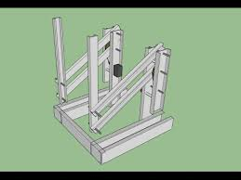

A 4 bar will be the easiest and most simple lift that you can make besides just a piece of metal and a motor, this lift is made by using one motor (or two if that amount of strength is needed but it probably won’t be) on each half of the lift to move two pieces of metal which are connected. To make this lift simply attach one piece of aluminum on an axle which is connected to a motor (preferably a torque motor but different situations may require different motors). Then, decide on a number of holes to be your set distance between the aluminum and place the next piece of aluminum there by attaching it to an axle but not to another motor. Do this again but with the motor on the opposite side and you will have the two completed halves of a basic 4 Bar lift.

# Double Reverse 4 Bar Lift:

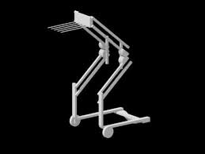

A Double Reverse 4 Bar (or DR4B) is a lift which is essentially two 4 bar lifts. This is the lift that you’ll want to use if you wish to reach greater heights than the regular 4 bar or if you need something with more strength. To build the DR4B you simply build the two halves of a 4 bar and then on the end of those where you would have attached something on your 4 bar, you build another 4 bar but this time with the bars of the lift facing the opposite direction as the first ones. You can chose based on how much strength you’ll need on whether or not to put two more motors on in the 2nd joint of the DR4B or you can just move the whole thing with the two on the 1st joint.